Week: 13
Experiment: 12
“Quantitative analysis of serum TSH hormone by Enzyme-Linked Immunosorbent Assay (ELISA)”
Total Marks (30 Marks):
1) Lab Performance (10 Marks):
Procedure:
Step 1: Add 50 µL of each standard, control serum, and sample.
Step 2: Add 100 µL of enzyme conjugate.
Step 3: Tap the plate for 15 seconds.
Step 4: Cover the plate and incubate for 60 minutes at 22–28°C.
Step 5: Discarding liquid from wells.
Step 6: Rinse 5 times with about 300 µL wash solution per well.
Step 7: After washing, tap the plate upside down on tissue paper to remove liquid.
Step 8: Add 100 µL of chromogen-substrate to each well.
Step 9: Cover the plate and incubate for 15 minutes in the dark at room temperature.
Step 10: Add 100 µL stop solution to each well.
Step 11: Read absorbance at 450 nm using an ELISA reader within 30 minutes.

2) Observation (5 Marks):
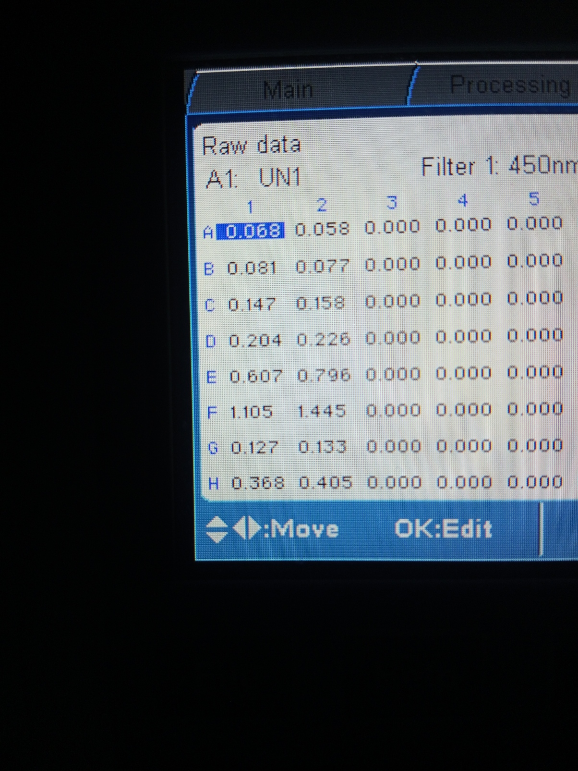
1ST Four rows look almost the same, dark yellowish color, for rows E and F, the substance show the color green. In G row, sharp yellow color is seen. And in the last row, light brownish color is seen.
3) Graph (2 marks):
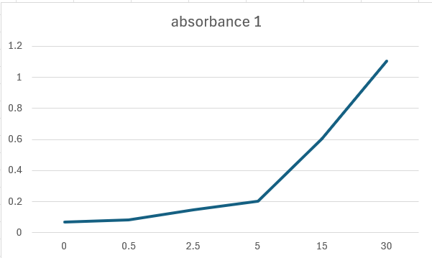

4) Calculation (5 marks):
(Explain how calculations were done using the graph shared above.)
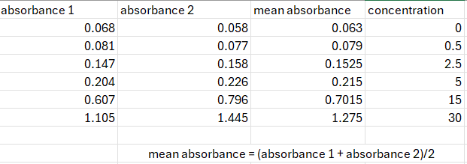

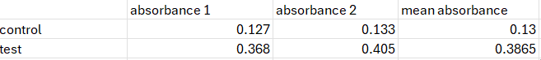

- We traced the mean absorbance of control and test on our mean absorbance graph.
- the corresponding values of mean absorbance gave us the following concentration
- control = 1.9 mIU/L
- test = 8.6 mIU/L

5) Picture of a well plate (2 marks):

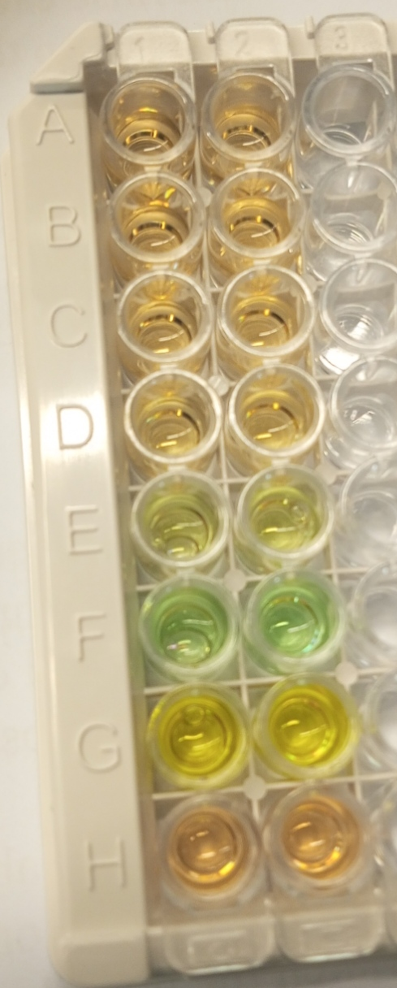

6) Result (4 Marks):
Absorbance readings were taken at 450 nm.
• A standard curve was prepared using six TSH concentrations: 0, 0.5, 2.5, 5, 15, and 30 mIU/L.
• The curve showed that mean absorbance increased with higher TSH concentrations.
• The highest mean absorbance recorded among the standards was 1.275 at 30 mIU/L.
• Mean absorbance values were calculated for both the Control and Test samples.
• Control Sample (Row G) Mean Absorbance: 0.130
• Test Sample (Row H) Mean Absorbance: 0.3865
• TSH concentrations for the unknown samples were determined by interpolating their absorbance values on the standard curve.
• Control Sample TSH Concentration: 1.9 mIU/L
• Test Sample TSH Concentration: 8.6 mIU/L
• The Test Sample shows a significantly higher TSH concentration than the Control Sample.
• This elevated TSH level suggests the Test Sample may indicate hypothyroidism.
• The Control Sample falls within the normal TSH range.

7) Explain how micropipette is used in steps (2 marks):

First set the amount of substance by rotating the button. Then single press it and dip the tip in liquid, after that release the button to suck the liquid, then double press the button, to release all the liquid in the wells.

8) Problems:
Due to our first time attempt, there is a bit difference in both of our readings.

